Oct. 28, 2019

Contact: Sandra Hutchison
Sheer Hubris Press
37 Bolivar Ave.
Troy, NY 12180
Phone 518-328-3633
hutchcopy@gmail.com or
sandrahutchison@sheerhubris.com

Contact for Sweet Flora Marketplace:
Nicole Wagner, 518-712-5500
sweetflorafarms@gmail.com

For Immediate Release:

Novel dramatizes challenges facing a “dreamer”
(TROY, NY) Local author Sandra Hutchison’s first three novels were set in New England, but her fourth takes place in and around where she now lives in Troy, New York. “Disorganize Me” is the story of a young couple who overcome cultural and class differences to fall in love, only to run into a much more significant hurdle when ICE knocks on the door. How much, it asks, is each willing to give up to try to stay together?
Hutchison hopes “Disorganize Me” will help readers empathize with the legal and emotional challenges facing immigrants who grew up in the United States and risk deportation even though they may know no other country. While her heroine is a professional organizer who was born and raised in the Capital Region and not immune from prejudice, her hero grew up in New York City and takes pride in his Puerto Rican origins, which would make him a citizen. Unfortunately, he’s wrong about where he was born.
To write the book, Hutchison drew on her knowledge of some Latinx cultures after 23 years of marriage to a “Nuyorican” who moved back to Puerto Rico as a child, as well as raising her son of Puerto Rican descent in the Capital Region. She set the novel early in the Obama administration before it implemented DACA (Deferred Action for Childhood Arrivals), both because that was a time of many deportations and because, she says, “I hoped it would help me avoid over-indulging my own political biases.”
She was fortunate enough to get help from an immigration attorney in keeping her character’s fictional situation realistic, since her attempts to get answers directly from Immigration and Customs Enforcement were not successful.
Hutchison is the author of the novels “The Awful Mess: A Love Story” (2013), “The Ribs and Thigh Bones of Desire” (2014), and “Bardwell’s Folly” (2016), all published by Sheer Hubris Press (“The Awful Mess” is also available as an audiobook from Tantor Media). After a long career in publishing and copywriting she now mostly focuses on her writing, but she also teaches composition part-time at Hudson Valley Community College.
Hutchison will read short excerpts from the novel and answer questions about writing and publishing Saturday, Nov. 16 at 2 pm at Sweet Flora Marketplace, a new gift shop featuring local artisans that is located in the 43 Mall in West Sand Lake, New York.

PRAISE FOR DISORGANIZE ME
“With compassion, warmth, and a clear eye for what matters, Hutchison shows us how messy love can be and, ultimately, how worth the trouble it really is." – Margo Catts, author of “Among the Lesser Gods” (Arcade, 2017)
"A nuanced, warm, and necessary read, especially now. I couldn't put it down." – Barbara Bos, Managing Editor @womenwriters
"...Hutchison weaves real-world issues into this contemporary novel with nuance and care and without overpowering the central story of two young people figuring out how they fit into society, their own families, and each other’s lives.” – Jennifer Klepper, author of “Unbroken Threads” (Red Adept, 2018)
PRAISE FOR SANDRA HUTCHISON
“A deftly crafted and consistently compelling read from cover to cover, ‘Bardwell's Folly: A Love Story’ is an extraordinary novel that underscores author Sandra Hutchison's genuine flair for originality and storytelling.” – Midwest Book Review Small Press Watch, April 2017
"It puts me in mind of Jane Austen, the moral mathematics here.... It renews me as a reader, to enjoy a book so much; and as a writer, see it done so well." – Tim Farrington, author of “The Monk Downstairs” and other novels (HarperCollins) (writing about “The Awful Mess”)
"Sandra Hutchison writes beautifully transparent and unpretentious prose. She creates complex characters and a vivid sense of place. Most of all, she tells a compelling story full of sorrow and humor with a benign detachment that leaves room for readers to draw their own conclusions. In other words, she's a first-rate writer." – Mary Maddox, Awesome Indies (writing about “The Ribs and Thigh Bones of Desire”)

DETAILS
Disorganize Me: A Love Story
By Sandra Hutchison
Sheer Hubris Press (2019)
$14.00 paperback (366 pp.) / $7.99 eBook
ISBN (paper): 978-0-9911869-6-9
Availability: Currently available as both eBook and paperback on Amazon.com, with “wide” distribution for this title and others through Ingram Spark and most eBook retailers beginning in November 2019.
Cover Photo: Please find attached, or download from here.

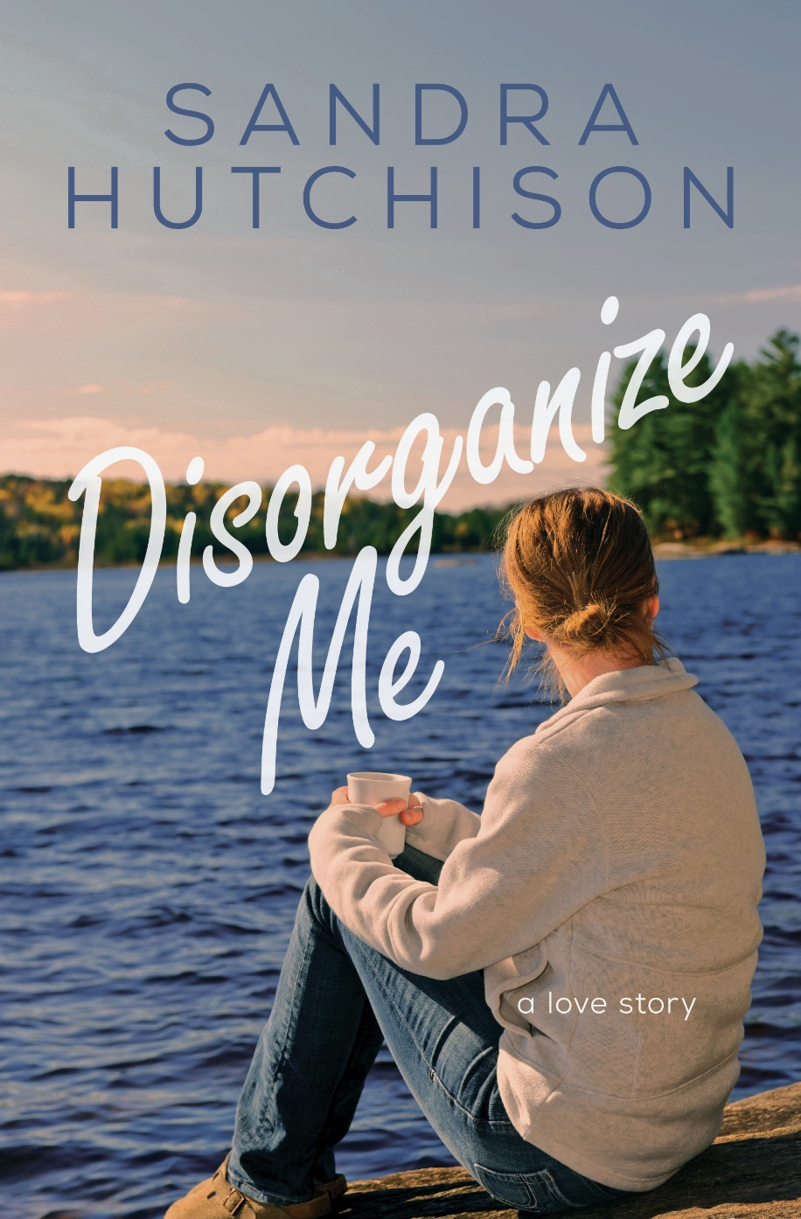

Author Photo: Please find attached, or download from here. No photo credit required.

